HANDOUT 2: PUT ON THE BERAKS, IT'S TURNING RED
HOW CAN I REGULATE MY EMOTIONS?
The traffic light

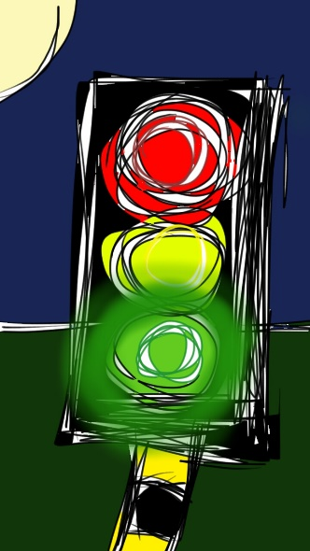
Recap and resume, go out, postpone the discussion
Self-verbalisations (I can control myself, some good comes out of this…)
Fix the volume, one step behind, breath 4-4-8
Go ahead!
Think!
Stop!
- Fix the volume: be aware of one's shoutings is not easy. You got it! Now look for a lower tone, feel it in your ears and try to maintain it during the whole conversation.
- One step behind: We use to invade the others' space when we get nervous. If it seems your interlocutor is really close, go one step behind, look at the ground (or aside) and breath deeply.
- 4-4-8: Breathing affects heart rate, sweating, sttutering...Try to feel how you breath. Breath in counting until 4, hold your breath counting until 4, breath out counting until 8. Note as your heart and body begin to relax.
- Self-verbalisations: Nobody like you can challenge your thoughts. Counter negatives automatic thoughts such as generalisations or seing things in purely white and black terms (“all”, “nobody”, “always”), sometimes it has or will not been the case.

