http://www.ycare.eu

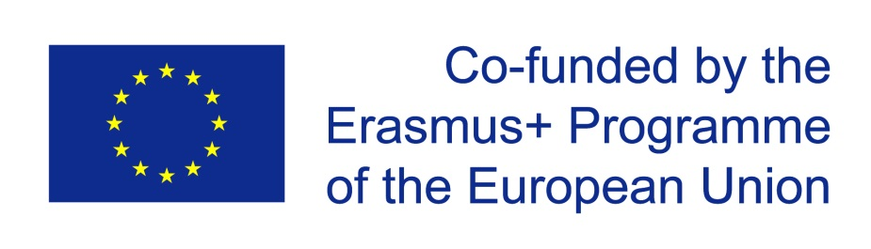

This project has been funded with support from the European Commission.
This publication reflects the views only of the author, and the
Commission cannot be held responsible for any use which may be made of the
information contained therein.

ERASMUS+ Strategic Partnership
Project Number 2015-1-NL01-KA202-008861

Project promotor and coordinator:
Verwey Jonker Instituut
Utrecht, Netherlands

Contact in <your country>
Your organisation’s name
Your address / email
Maybe also contact person

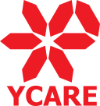

Youth Counselling against Radicalisation

A Holistic Approach to Support Vulnerable Adolescents

Radicalisation of juveniles: What can counsellors and advisers do?
Youth counsellors and advisers, but also teachers and trainers – called „first-liners“ - need new skills and competences to be better prepared to deal with intercultural tensions between diverse groups of learners. They should be able to detect, at an early stage, indicators of radicalisation among their learners. However, many of them have had their vocational education years ago, and many of them are completely or partially unprepared to the changes in the way in which our society is organized and which conceptual aspects of radicalisation pose a threat.

Our project will provide youth counsellors, teachers and advisers with effective tools information and information about good practice and methods, in order to help them do their work better. They will be able to acquire skills and knowledge to apply interventions in a preventive stage, and to focus on self-esteem, empathy towards out-groups and managing negative emotions. In this way, the project also aims to be one of the concrete actions to reach the Horizon 2020 goals, but also some primary aims of the Secure Societies Challenge which is about undertaking innovation activities needed to protect our citizens, society and economy as well as our political stability and wellbeing, and to fight crime and terrorism.

Click
http://www.ycare.eu

or contact

Your organisation
Name
Email
Website

The Strategic Erasmus+ Partnership consists of seven organisations. They have been previously involved in several informal networks or European project collaboration. What unites them is their dedication to the theme of the project, i.e. work with marginalised young people. The activities and expected outcomes fit into their strategy insofar that the identification of approaches, best practice examples and materials for detecting radicalisation at an early stage is in line with their educational activities and course programmes.

Verwey Jonker Instituut (NL)
Association Culture and Work (DE)
E-C-C Association for Interdisciplinary Education and Consulting (AT)
INTEGRA Institute for Development of Human Potentials (SI)
QUALED Qualification and Education (SK
ALDAIMA (ES)
Meath Partnership (IE)

